# What is Java?

Java is a high-level, platform independent, write once use everywhere programming language used to various including web development, android app development, desktop software and server-side applications.

# Features of Java

1. Platform Independence: Java is designed to be platform-independent, thanks to the use of the Java Virtual Machine (JVM). This means that Java applications can run on any system with a compatible JVM, making it a "write once, run anywhere" language.
2. Object-Oriented: Java is a fully object-oriented programming language, emphasizing the use of objects and classes for code organization and reusability.
3. Strongly Typed: Java enforces strong typing, which helps catch errors at compile time and promotes code reliability.
4. Automatic Memory Management: Java incorporates automatic garbage collection, relieving developers from manual memory management, reducing memory-related errors and vulnerabilities.
5. Multithreading: Java offers robust support for multithreading, making it suitable for concurrent and parallel programming.
6. Security: Java includes various security features, such as a security manager, to create secure and reliable applications.
7. Rich Standard Library: Java provides a vast standard library that simplifies common programming tasks and offers numerous built-in classes and methods.
8. Exception Handling: Java includes a robust exception-handling mechanism to manage and recover from runtime errors.
9. Portability: Java's platform independence and bytecode compilation make it highly portable, ensuring consistent behaviour across different systems.
10. Large Ecosystem: Java has a massive and active community, resulting in a rich ecosystem of libraries, frameworks, and tools for various application domains.
11. Dynamic Class Loading: Java supports dynamic class loading, allowing classes to be loaded on-demand, which is useful for applications that need to adapt to changing requirements.
12. High Performance: Modern Java virtual machines (JVMs) are optimized for high performance, with just-in-time (JIT) compilation and various runtime optimizations.
13. Interoperability: Java can be integrated with other programming languages, often via Java Native Interface (JNI) or through various interop mechanisms.
14. Network Support: Java includes libraries for network programming, enabling the development of networked and distributed applications.
15. Community Support: Java has a strong developer community with extensive documentation, forums, and resources, making it easy to find help and guidance.

# JDK – Java Development Kit

JDK is a cross-platform software development environment which includes set of tools and libraries required for Java based developments.

JDK = JRE + Development Tools

The Java Development Kit is an implementation of one of the Java Platform:

1. Standard Edition (Java SE),
2. Java Enterprise Edition (Java EE),
3. Micro Edition (Java ME)

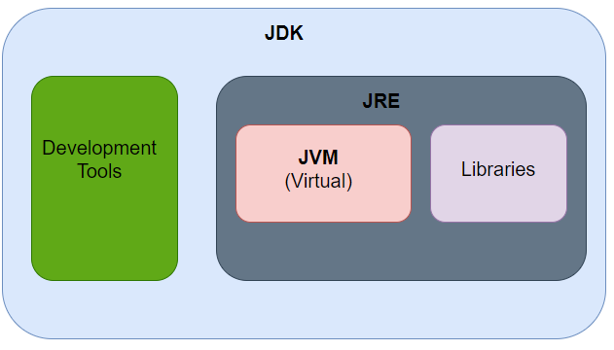

# JRE – Java Runtime Environment

The JRE is a software package that provides the runtime environment necessary for executing Java applications on a computer. It contains JVM and Libraries needed to execute JAVA applications.

# JVM – Java Virtual Machine

The Java Virtual Machine is a virtual machine that provides a runtime environment for Java applications and programs.

Java is platform independent due to JVM.

# Lifecycle of Java Code

We write Java source code using a text editor or IDE. At this point we are making a USE of JDK by writing a code. Java source code is compiled with the help of javac command which is part of JDK. Javac translates the Java source code into platform-independent bytecode instructions. These bytecode instructions are stored in a .class file with the same name as the source file.